INTRODUCTION TO VERILOG HDL

Verilog as HDL

Verilog has a variety of constructs as part of it. All are aimed at providing a functionally tested and a verified design description for the target FPGA or ASIC. The language has a dual function – one fulfilling the need for a design description and the other fulfilling the need for verifying the design for functionality and timing constraints like propagation delay, critical path delay, slack, setup, and hold times.

Levels of Design Description

The components of the target design can be described at different levels with the help of the constructs in Verilog. In Verilog HDL a module can be defined using various levels of abstraction. There are four levels of abstraction in verilog.
They are:
1. Circuit Level
2. Gate Level
3. Data Flow Level
4. Behavioral Level

Circuit Level

At the circuit level, a switch is the basic element with which digital circuits are built. Switches can be combined to form inverters and other gates at the next higher level of abstraction. Verilog has the basic MOS switches built into its constructs, which can be used to build basic circuits like inverters, basic logic gates, simple 1-bit dynamic and static memories. They can be used to build up larger designs to simulate at the circuit level, to design performance critical circuits. The below Figure1 shows the circuit of an inverter suitable for description with the switch level constructs of Verilog.

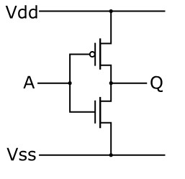

Figure 1 CMOS inverter

Gate Level

At the next higher level of abstraction, design is carried out in terms of basic gates. All the basic gates are available as ready modules called “Primitives.” Each such primitive is defined in terms of its inputs and outputs. Primitives can be incorporated into design descriptions directly. Just as full physical hardware can be built using gates, the primitives can be used repeatedly and judiciously to build larger systems. Figure 2 shows an AND gate suitable for description using the gate primitive of Verilog.

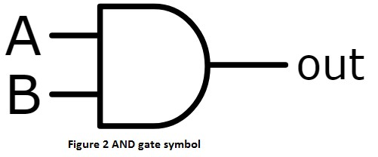

The gate level modeling or structural modeling as it is sometimes called is akin to building a digital circuit on a bread board, or on a PCB. One should know the structure of the design to build the model here. One can also build hierarchical circuits at this level. However, beyond 20 to 30 of such gate primitives in a circuit, the design description becomes unwieldy; testing and debugging become laborious.

Data Flow

Data flow is the next higher level of abstraction. All possible operations on signals and variables are represented here in terms of assignments. All logic and algebraic operations are accommodated. The assignments define the continuous functioning of the concerned block. At the data flow level, signals are assigned through the data manipulating equations. All such assignments are concurrent in nature. The design descriptions are more compact than those at the gate level.

Figure 3 shows an A-O-I relationship suitable for description with the Verilog constructs at the data flow level.

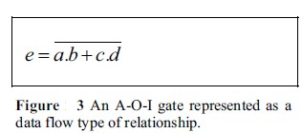
Behavioral Level

Behavioral level constitutes the highest level of design description; it is essentially at the system level itself. With the assignment possibilities, looping constructs and conditional branching possible, the design description essentially looks like a “C” program. A module can be implemented in terms of the design algorithm. The designer no need to have any knowledge of hardware implementation. The statements involved are “dense” in function. Compactness and the comprehensive nature of the design description make the development process fast and efficient. Figure 4 shows an A-O-I gate expressed in pseudo code suitable for description with the behavioral level constructs of Verilog.

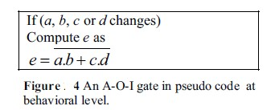

MODULE

Any Verilog program begins with a keyword – called a “module.” A module is the name given to any system considering it as a black box with input and output terminals as shown in Figure. The terminals of the module are referred to as ‘ports’. The ports attached to a module can be of three types:
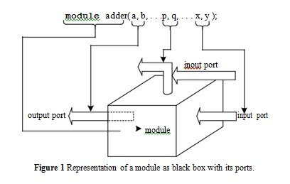
- Input ports through which one gets entry into the module; they signify the input signal terminals of the module.
- Output ports through which one exits the module; these signify the output signal terminals of the module.
- Input ports: These represent ports through which one gets entry into the module or exits the module; These are terminals through which signals are input to the module sometimes; at some other times signals are output from the module through these.
Whether a module has any of the above ports and how many of each type are present depend solely on the functional nature of the module. Thus one module may not have any port at all; another may have only input ports, while a third may have only output ports, and so on. All the constructs in Verilog are centered on the module. They define ways of building up, accessing, and using modules. The structure of modules and the mode of invoking them in a design are discussed here.
A module comprises a number of “lexical tokens” arranged according to some predefined order. The possible tokens are of seven categories:
- White spaces
- Comments
- Operators
- Numbers
- Strings
- Identifiers
- Keywords
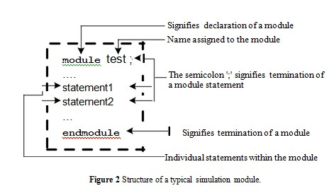
The rules constraining the tokens and their sequencing will be dealt with as we progress. For the present let us consider modules. In Verilog any program which forms a design description is a “module.” Any program written to test a design description is also a “module.” The latter are often called as “stimulus modules” or “test benches.” A module used to do simulation has the form shown in Figure .
Verilog takes the active statements appearing between the “module” statement and the “endmodule” statement and interprets all of them together as forming the body of the module. Whenever a module is invoked for testing or for incorporation into a bigger design module, the name of the module (“test” here) is used to identify it for the purpose.

Operators
Operators are of three types: unary, binary, and ternary. Unary operators precede the operand. Binary operators appear between two operands. Ternary operators have two separate operators that separate three operands.
a = ~ b; // ~ is a unary operator. b is the operand
a = b && c; // && is a binary operator. b and c are operands
a = b ? c : d; // ?: is a ternary operator. b, c and d are operands

Number Specification
There are two types of number specification in Verilog: sized and unsized.

Sized numbers
Sized numbers are represented as <size> '<base format> <number>.
<size> is written only in decimal and specifies the number of bits in the number. Legal base formats are decimal ('d or 'D), hexadecimal ('h or 'H), binary ('b or 'B) and octal ('o or 'O). The number is specified as consecutive digits from 0, 1, 2, 3, 4, 5, 6, 7, 8, 9, a, b, c, d, e, f. Only a subset of these digits is legal for a particular base. Uppercase letters are legal for number specification.
4'b1111 //This is a 4-bit binary number
12'habc // This is a 12-bit hexadecimal number
16'd255 //This is a 16-bit decimal number.

Unsized numbers
Numbers that are specified without a <base format> specification are decimal numbers by default. Numbers that are written without a <size> specification have a default number of bits that is simulator- and machine-specific (must be at least 32).
23456 // This is a 32-bit 'hc3 // This is a 32-bit 'o21 // This is a 32-bit decimal number by default hexadecimal number octal number

X or Z values
Verilog has two symbols for unknown and high impedance values. These values are very important for modeling real circuits. An unknown value is denoted by an x. A high impedance value is denoted by z.
12'h13x // This is a 12-bit hex number; 4 least significant bits unknown
6'hx // This is a 6-bit hex number
32'bz // This is a 32-bit high impedance number
An x or z sets four bits for a number in the hexadecimal base, three bits for a number in the octal base, and one bit for a number in the binary base. If the most significant bit of a number is 0, x, or z, the number is automatically extended to fill the most significant bits, respectively, with 0, x, or z. This makes it easy to assign x or z to whole vector. If the most significant digit is 1, then it is also zero extended.

Negative numbers
Negative numbers can be specified by putting a minus sign before the size for a constant number. Size constants are always positive. It is illegal to have a minus sign between <base format> and <number>. An optional signed specifier can be added for signed arithmetic.
-6'd3 // 8-bit negative number stored as 2's complement of 3 -6'sd3 // Used for performing signed integer math 4'd-2 // Illegal specification
Value Set or Logic Values
Verilog supports four values and eight strengths to model the functionality of real hardware. The four value levels are listed in Table below.
Value Level | Condition in Hardware Circuits
0 | Logic zero, false condition
1 | Logic one, true condition
x | Unknown logic value
Z | High impedance, floating state

Data Types
The data handled in Verilog fall into two categories:
(i) Net data type
(ii) Variable data type
The two types differ in the way they are used as well as with regard to their respective hardware structures. Data type of each variable or signal has to be declared prior to its use. The same is valid within the concerned block or module.
Nets
A net signifies a connection from one circuit unit to another. Such a net carries the value of the signal it is connected to and transmits to the circuit blocks connected to it. If the driving end of a net is left floating, the net goes to the high impedance state. A net can be specified in different ways.
wire: It represents a simple wire doing an interconnection. Only one output is connected to a wire and is driven by that.
tri: It represents a simple signal line as a wire. Unlike the wire, a tri can be driven by more than one signal outputs.
Nets are one-bit values by default unless they are declared explicitly as vectors. The terms wire and net are often used interchangeably.

Operator Types

Verilog provides many different operator types. Operators can be arithmetic, logical, relational, equality, bitwise, reduction, shift, concatenation, or conditional. Some of these operators are similar to the operators used in the C programming language. Each operator type is denoted by a symbol. The following table shows the complete listing of operator symbols classified by category.

Operator Type | Symbol | Operation Performed
Arithmetic | + | Addition
 | - | Subtraction (also Unary negation)
 | * | Multiplication
 | / | Division (returns quotient)
 | % | Modulus (returns remainder)
 | + (unary) | Unary plus (sign)
 | - (unary) | Unary minus (sign)
Relational | > | Greater than
 | >= | Greater than or equal to
 | < | Less than
 | <= | Less than or equal to
Equality | == | Logical equality (results in x if x or z are involved)
 | != | Logical inequality (results in x if x or z are involved)
 | === | Case equality (compares all 4 states, including x and z)
 | !== | Case inequality (compares all 4 states, including x and z)
Logical | ! | Logical NOT
 | && | Logical AND (returns 0 or 1)
 | || | Logical OR (returns 0 or 1)
Bitwise | ~ | Bitwise NOT (complement)
 | & | Bitwise AND
 | | | Bitwise OR
 | ^ | Bitwise XOR
 | ~& | Bitwise NAND
 | ~| | Bitwise NOR
 | ^ or ^ | Bitwise XNOR
Shift | << | Logical left shift
 | >> | Logical right shift

Shift operators are useful because they allow the designer to model shift operations, shift-and-add algorithms for multiplication, and other useful operations.

Table: Operator Precedence

Operators | Operator Symbols | Precedence
Unary | + - ! ~ | Highest  precedence
Multiply, Divide, Modulus | * / %
Add, Subtract | + -
Shift | << >>
Relational | < <= > >=
Equality | == != === !==
Logical | &&  ||
Conditional | ?: | Lowest precedence

Behavioral Modeling
Behavioral modeling is the highest level of abstraction in the Verilog HDL. The other modeling techniques are relatively detailed. They require some knowledge of how hardware or hardware signals work. The abstraction in this modeling is as simple as writing the logic in C language. This is a very powerful abstraction technique. All that a designer need is the algorithm of the design, which is the basic information for any design.
Most of the behavioral modeling is done using two important constructs: initial and always. All the other behavioral statements appear only inside these two structured procedure constructs.

The Initial Construct
The statements which come under the initial construct constitute the initial block. The initial block is executed only once in the simulation, at time 0. If there is more than one initial block, then all the initial blocks are executed concurrently. The initial construct is used as follows:
initial begin reset=1'b0; clk=1'b1; end
or initial
clk = 1'b1;
In the first initial block there are more than one statements hence they are written between begin and end. If there is only one statement then there is no need to put begin and end.

The always construct
The statements which come under the always construct constitute the always block. The always block starts at time 0, and keeps on executing all the simulation time. It works like a infinite loop. It is generally used to model a functionality that is continuously repeated.
always
#5clk=~clk;
initial
clk = 1'b0;
The above code generates a clock signal clk, with a time period of 10 units. The initial blocks initiates the clk value to 0 at time 0. Then after every 5 units of time it toggled, hence we get a time period of 10 units. This is the way in general used to generate a clock signal for use in test benches.
always@(posedge clk, negedge reset)
begin
a = b + c;
d = 1'b1;
end
In the above example, the always block will be executed whenever there is a positive edge in the clk signal, or there is negative edge in the reset signal. This type of always is generally used in implement a FSM, which has a reset signal.
always @(b,c,d)
begin
a = ( b + c )*d;
e = b | c;
end
In the above example, whenever there is a change in b, c, or d the always block will be executed. Here the list b, c, and d is called the sensitivity list.
In the Verilog 2000, we can replace always @(b,c,d) with always @(*), it is equivalent to include all input signals, used in the always block. This is very useful when always blocks are used for implementing the combination logic.

